# Create a new EC2 Instance

Launch instance

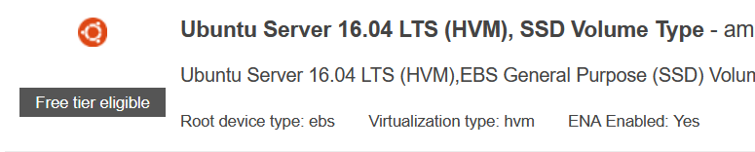



Keep defaults on steps 3, 4 and 5.

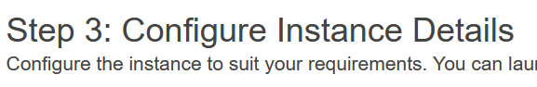

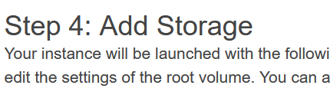

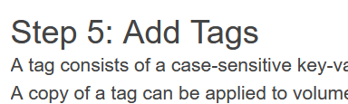

Config Sec Group

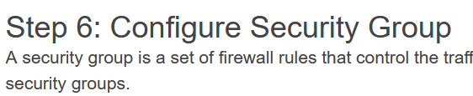

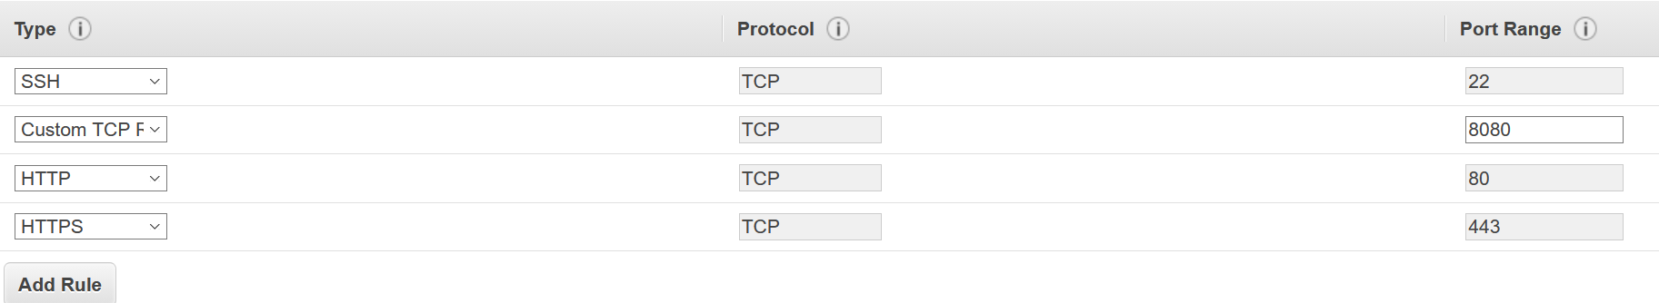

Keep Step 7 default and launch.



Create new key pair

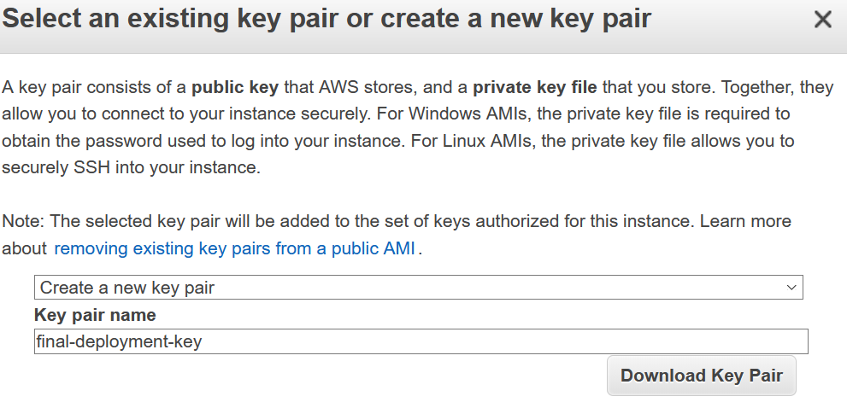

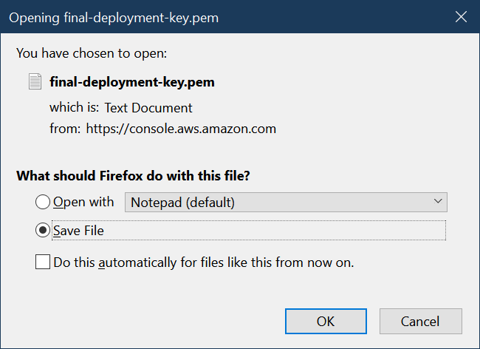





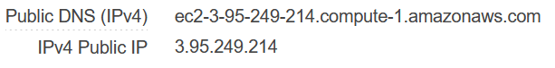

# SSH Login

Open PuTTYgen

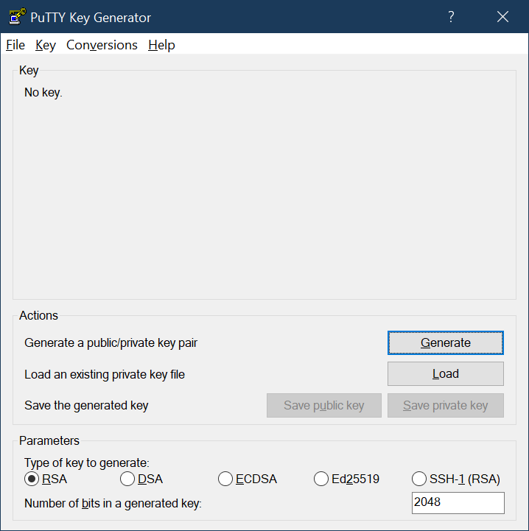

Load pem file.  
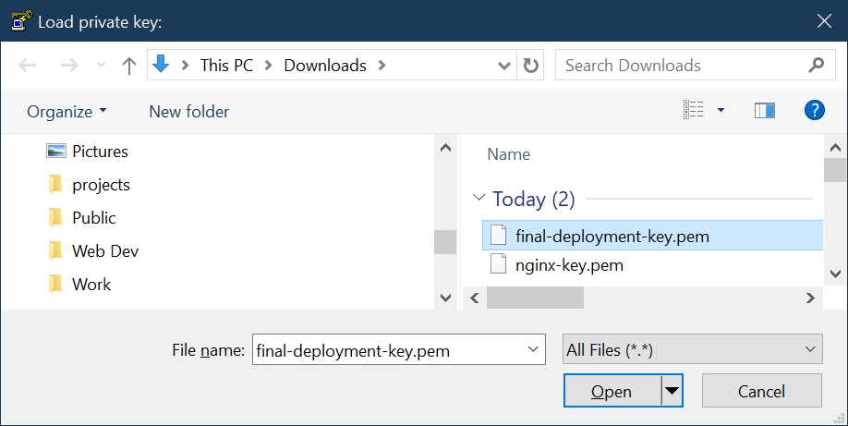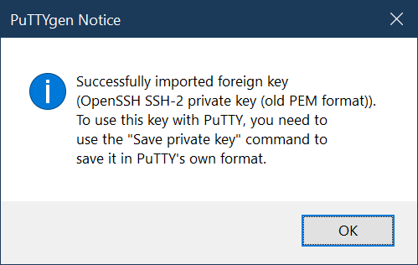



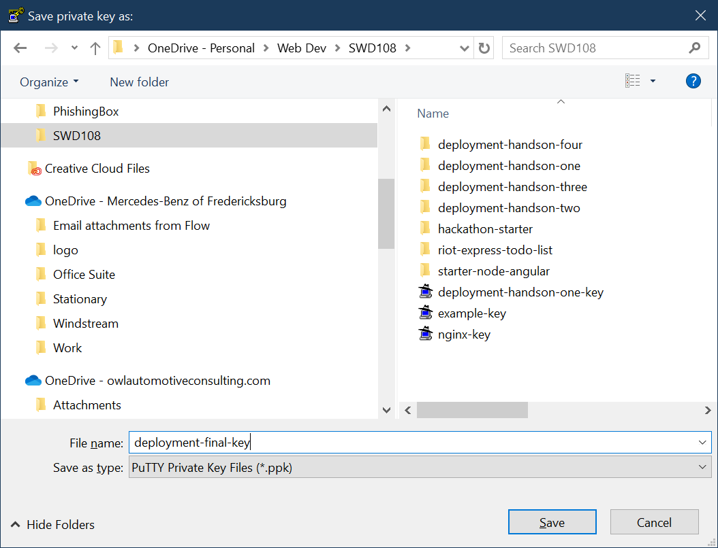

Add ppk to pageant keys

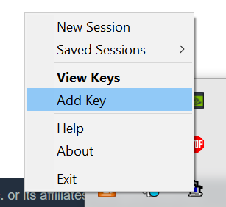

Connect with PuTTY

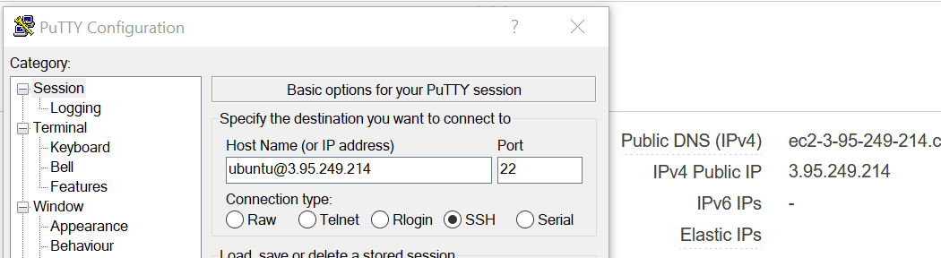

Connected and verified private IP

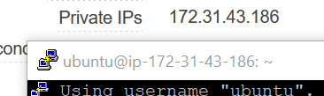

Install git cloned project, npm, node, and mongo db install/run on ec2. Verified;  
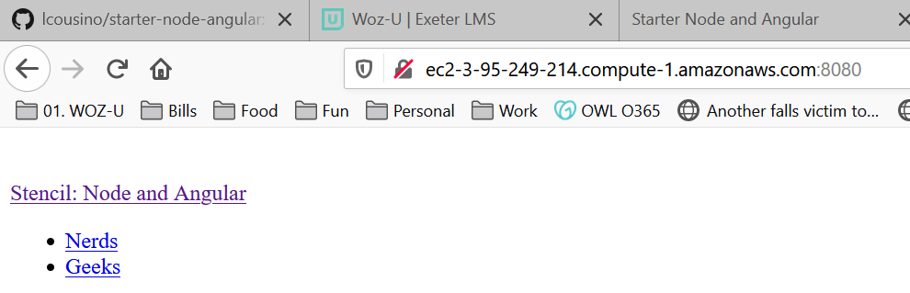

# Fork and Clone Project

Fork:







Clone:

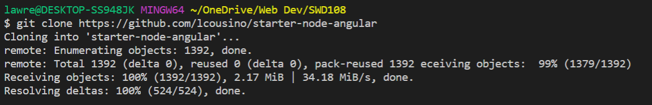

Ran npm install and started Mongo DB, then started npm. Lastly verified running locally.

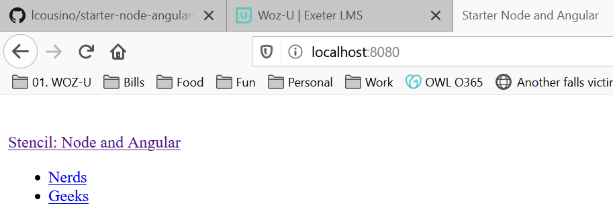

# Connect with Travis CI

Create travis.yml file



# Deploy Script

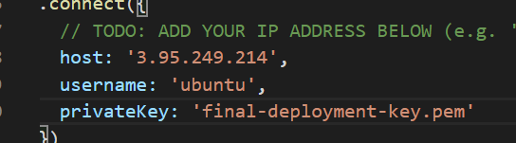

Create deploy.sh file

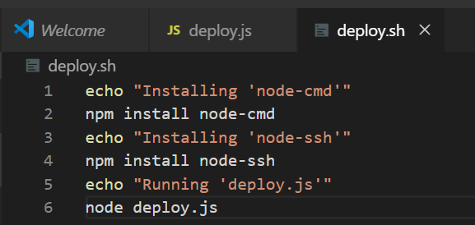

# Configure Nginx